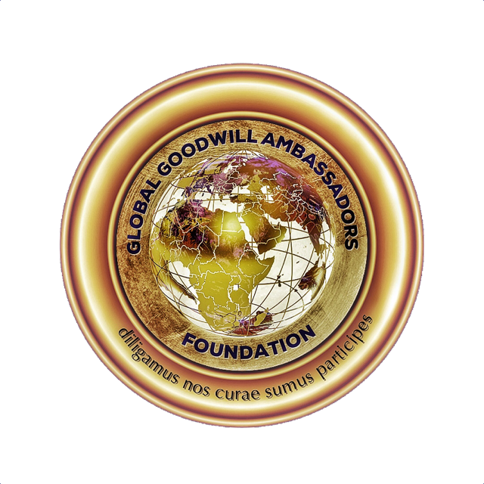
Global Goodwill Ambassadors Foundation
Harassment Policy/Social Media Policy

- Purpose
Global Goodwill Ambassadors Foundation (hereinafter referred to as Foundation is committed to providing an environment for members, volunteers) that is comfortable, safe and free from harassment of any kind. Any type of harassment is a violation of our Code of Ethics policy and will result in loss of your Global Goodwill Ambassador designation and may be illegal.
Social Media: We understand that social media can be a fun and rewarding way to share your life and opinions with family, friends and collogues around the world. However, use of social media also present certain risks and carries with it certain responsibilities. To assist you in making responsible decision about your use of social media, we have established these guidelines for appropriate use of social media. This policy covers all content and any form of harassment – from unkind words to unwanted romantic advances to hate speech to bullying – by any GGA.
Social media includes all means of communication or posting information or content of any sort on the internet, including to your own or someone else’s web blog, journal or diary, personal website, social networking or affinity web site, web bulletin board or chat room, whether or not associated or affiliated with the Foundation, as well as any other form of electronic communication. Ultimately, you are solely responsible for what you post online. Before creating online content, consider some of the risks and rewards that are involved. Keep in mind that any of your conduct that adversely affects the Foundation, your fellow associates or otherwise adversely affects members may be result in loss of your GGA designation.
Global Goodwill Ambassadors Foundation is a non-political, non-biased foundation and believe all people are equal regardless of their race, color, religious beliefs, gender, sexual orientation, geographical residence, socio-economic status or creed.

As an ambassador and someone required to adhere to the rules of personal decorum and ethics, as a GGA you are not permitted, allowed, authorized, admissible, nor is it condoned to talk to, continue chats, send messages, pictures or links, that includes, involves or incites lewd and lascivious behaviors.

https://www.globalgoodwillambassadors.org/

Page 1 of 5 rev: 1/31/2020

- Definition
Harassment can take many forms. It may be, but is not limited to the following: words, signs, jokes, pranks, intimidation, physical contact or violence. Harassment does not have to be sexual in nature. Sexual harassment may include unwelcome sexual advances; request for sexual favors, pictures; or other verbal or physical contact of a sexual nature when such a conduct creates an intimidating environment, either implicitly or explicitly. It is not the intent of the behavior by the offender that determines if harassment has occurred by whether the behavior is welcome by the receiver.
Always be fair and courteous to everyone and do not post video, audio or text that can reasonably be viewed as malicious, obscene, threatening or intimidating, that disparage others or that might constitute harassment or bullying. Examples of such conduct might include offensive posts meant to intentionally harm someone’s reputation or ports that could contribute to a hostile work environment on the basis of race, sex, disability, religion.
*Do not use the Foundation logo or create a link on your website to our website without permission from Lisa Jones, President and COO.
- Responsibility
Global Goodwill Ambassadors is dedicated to keeping our environment free of any type of harassment. If you become aware of an incident of harassment, whether by witnessing the incident or being told of it, please report this to Lisa A. Jones, President/COO, Lisa@globalgoodwillambassadors.com. Screenshots of anyone breaking this code of ethics/harassment policy are very helpful.
If you are able to do so without conflict or danger, tell the harasser as clearly as possible that the behavior is unwelcome.
Upon receipt of complaint, our Board of Directors will investigate such complaint including disciplinary action that should secure and maintain an environment free of harassment.

https://www.globalgoodwillambassadors.org/

Page 2 of 5 rev: 1/31/2020

- Confidentiality

The Foundation, including all persons to whom this violation of Harassment Policy has been reported and persons who have become aware of the complaint, must maintain confidentiality, to the extent possible given the need to investigate. All complaints shall be considered confidential to the maximum extent possible.

- Retaliation
The Foundation may not retaliate against any victim, or witness, who reports a violation of this Harassment Policy.

- Declaration
All Global Goodwill Ambassadors who have received our designation, have agreed to our Code of Ethics which contains a no harassment agreement and all understand that when submitting our form via the website to become a Global Goodwill Ambassador have agreed to this policy and understand this policy contained in our Code of Ethics.

Please note that we are LinkedIn based and have groups on WhatsApp and other social media forums which give you the right to block any individual for any reason and also report according to forum guidelines. We ask that everyone maintain professionalism at all times. Global Goodwill Ambassadors Foundation also does not take responsibility for action of anyone that is not part of GGA and cannot investigate these matters.
We ask that everyone use proper safety precautions when meeting anyone in person by choosing a well-lit public venue and suggest meetings that take place during the daytime.

Please know your surroundings and inform someone where you may be in case of emergencies. Violations of any type of harassment/abuse should be reported to your local authorities as soon as possible.

https://www.globalgoodwillambassadors.org/

Page 3 of 5 rev: 1/31/2020
Adherence to our full GGA Code of Ethics is mandatory at all times.
Global Goodwill Ambassadors Foundation: Code of Ethics
“The following Code of Ethics must be followed and upheld by each member at all times. Any new members read and agree to this through submitting our information form via the website.”
NO SOLICITATIONS OR YOU WILL LOSE YOUR GGA DESIGNATION
DO NOT SOLICIT FOR FUNDS IN GGA GROUPS OR IN PRIVATE MESSAGES TO GGAS
Thank you for your interest in becoming recognized as a GLOBAL GOODWILL AMBASSADOR.
You should add your volunteer, charitable or humanitarian work inclusive of any related to the Sustainable Development Goals on your LinkedIn profile under Experience/Volunteer- Causes.
Once you do that, read the following Global Goodwill Ambassadors Code of Ethics.
Your nomination will then be submitted to the appropriate Continental GGA board for determination.
*WE ARE EU GDPR COMPLIANT*
CODE OF ETHICS, BEHAVIOR AND MORALS
In consideration of my nomination as a Global Goodwill Ambassador, I agree to the following:
- I believe all people are equal regardless of their race, color, religious beliefs, gender, sexual orientation, geographical residence, socio-economic status or creed.
- I will proudly present the Global Goodwill Ambassadors (GGA) designation on my LinkedIn profile in accordance to the Initiative’s instructions.
- I will accept the presentation of my designation and thank the people who welcome and congratulate me.
- In accordance with the GGA title, I will respect all people and never support, promote, or propagate hatred or hate speech toward anyone.
- I will not participate in the attack on anyone’s character.
- I will avail myself and endeavor to participate in Global Goodwill Ambassador Humanitarian Initiatives.

https://www.globalgoodwillambassadors.org/

Page 4 of 5 rev: 1/31/2020

- I will never use the Global Goodwill Ambassadors logo in any form of solicitation, inclusive of solicitation of any Global Goodwill Ambassador.
- I acknowledge the volunteer, charitable, or Humanitarian work on my LinkedIn Profile is accurate and understand this information is being confirmed to evaluate my Nomination.
- If at any time, for any reason, I wish to no longer be perceived as a person of Goodwill, I will privately notify my country or continent chairperson. At that time, my designation profile will be deleted.
- Anyone leaving GGA will no longer be eligible for this designation in the future.
By completing our submission form, you agree to all policies and understand that breaking policies will result in removal of your GGA designation.

https://www.globalgoodwillambassadors.org/

Page 5 of 5 rev: 1/31/2020

